Deep Learning-Based Mapping of Protein Diffusion in Living Cells at Single-Molecule Resolution

**step4_main_mobilityPALM.mlapp**

**User’s Guide**

**Processing MPALM Data**

This document outlines the workflow for rendering MPALM figures using our MATLAB App. Before starting, ensure that you have processed your raw single-molecule data using **step1_UNet_segmentation**, **step2_single_molecule_selection**, and **step3_Deep-SnapTrack**, and generated the following two files (if default settings and file naming were used):

* Blurdata_UNet_mask_MBX_20240620_epoch20_Ch1.mat
* UNet_mask_MBX_20240620_epoch20_Ch1_SR_pred_v3.csv

Then you can launch this app and proceed with the following steps to render MPALM figures

**Step 1: Loading the Data**

**1.1 Setting the Parameters**

Before loading the data files, you need to configure the following parameters manually:

* **D-SR constant**: This constant defines the correlation between the diffusion coefficient (*D*) and the square of the SR area.
  + Default values:

**1162** for a 30ms exposure time.

**2007** for a 100ms exposure time.

Both are generated by fitting to simulated dataset.

* **Max allowed photon**: Specifies the upper limit of photons for single localizations.
  + Default: **Inf** (no limit).
* **Min allowed photon**: Specifies the lower limit of photons for single localizations.
  + Default: **0**.
* **Camera pixel size (nm)**: The physical size of camera pixels used for raw data acquisition.
  + Recommended value: **110 nm**, as smaller pixel sizes improve performance.
* **Exposure time (s)**: The time duration for which the camera captures raw data.
  + Default: **0.0305 s** (includes a 0.5ms strobe for the camera).
* **MinLogD and MaxLogD**: Defines the range of diffusion coefficients (*D*) used for primary quantification of MPALM data in the right panel.
  + Default values: **-3** and **2**.

**1.2 Loading MPALM Results**

After setting the parameters, press the **Load Ch1** button. This will open an interface for file selection. Select the .mat and .csv files mentioned earlier. Depending on the size of your dataset, loading may take a few seconds to several minutes. Once completed, the lamp will turn green and the primary quantification results will be displayed in the right panel.

**1.3 Visualization of Primary Quantification Results**

The right panel provides two key pieces of information about your uploaded MPALM results:

1. **Distribution of diffusion coefficient (*D*):** A histogram that displays the distribution of *D* across all localizations. This visualization helps you select the appropriate range of *D* for the next step in MPALM rendering.
2. **Localizations per frame:** This graph serves as a quality control metric, reflecting the stability of your data over the acquisition period.

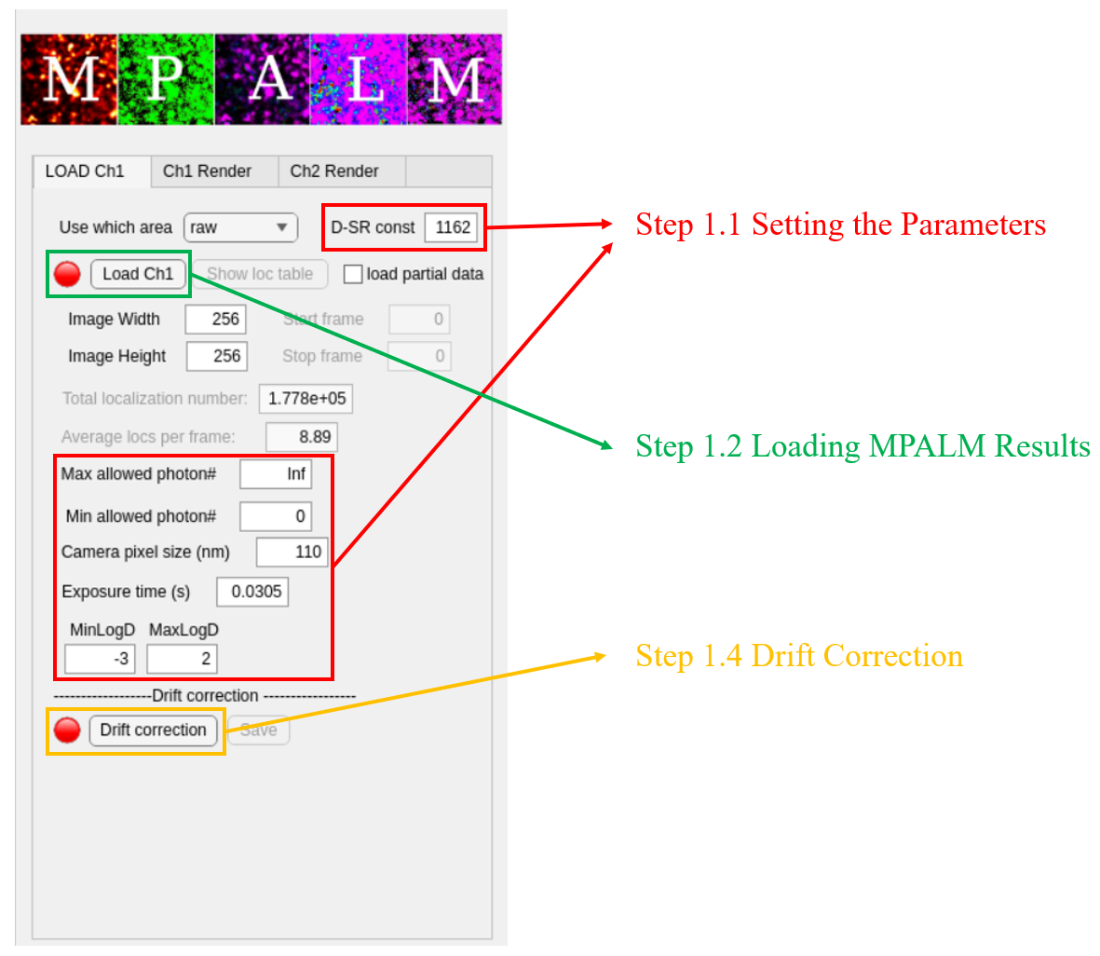 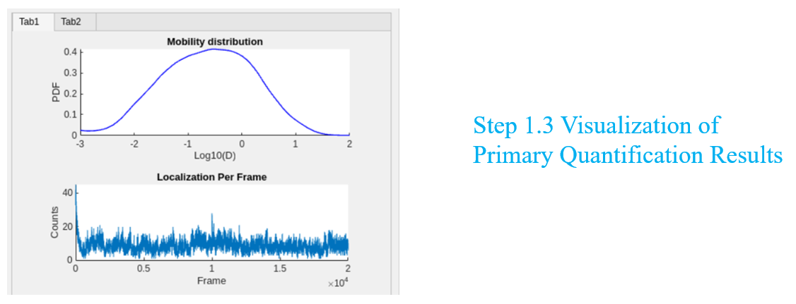

**1.4 Drift Correction**

You can apply drift correction by pressing **Drift correction** button. Once completed, the lamp will turn green. This app supports drift correction with three available methods:

1. **Using sequentially captured bulk images:**

This method calculates the cross-correlation between each corresponding time point of sequential bulk images. Ensure that your bulk images are named sequentially, and type in the prefix of your files in selected folder.

1. **Using sequentially captured brightfield images:**

This method optimizes the calculation of cross-correlation between each corresponding time point of sequential bulk images (Wester et al). Again, ensure that your bulk images are named sequentially, and type in the prefix of your files in selected folder.

1. **Using all localizations:**

This method calculates the cross-correlation between frames based on all detected localizations. Though some parameters need to be configured manually, no additional files are required for this method.

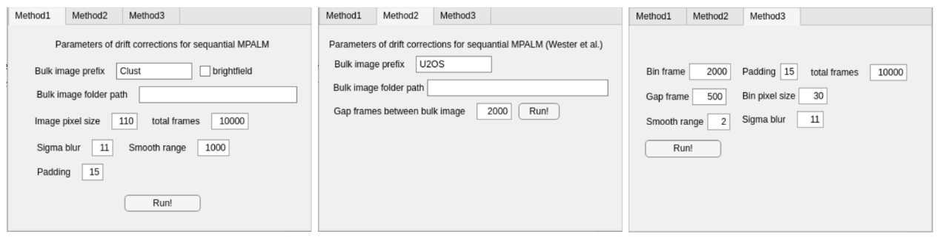

**Step 2: Rendering MPALM Figures**

**2.1 Quick Check on PALM Results**

After successfully loading the data, press the **Ch1 Render** button to begin the rendering process for MPALM figures. Before proceeding, you need to manually configure the following parameters:

* **Render pixel size (nm):** This determines how localizations are binned into pixels in the final figure.
  + Default:30nm.
* **Render sigma (nm):** This defines the size of the Gaussian kernel used during PALM image rendering.
  + Default: 30nm.
* **minDensity and maxDensity:** This specifies the density range in the rendered PALM figure. Pixels with density values beyond this range will be adjusted to the defined minimum/maximum values.

Once the parameters are set, press the **PALM!** button to generate the initial PALM figure. A panel will then appear, allowing you to fine-tune the **min/max Density** and adjust the contrast of the figure for optimal visualization.

* 1. **Segmentation of MPALM Data**

(Optional) This app provides a binary segmentation of MPALM data in case you want to focus on immobile molecules. Set **min mobile D** to a threshold of your interest and press **binary PALM** button. A quick check of segmentation will be shown and the lamp will turn green once segmentation finishes.

**2.3 Rendering MPALM Figures**

This is the final step in generating MPALM figures. Before proceeding, configure the following parameters:

* **Min log(D) and Max log(D):** Used for color mapping in MPALM rendering via the HSV method, where colors represent the diffusion coefficient (*D*). Pixels with *D* values outside this range will not be assigned new colors. You are recommended to set these values based on the primary quantification results.
* **Molecule type:** If segmentation has been applied, you can choose to render MPALM figures using only the localizations of specific molecules of your interest.

After setting the parameters, press the **Mobility PALM!** button to generate your final MPALM figures.

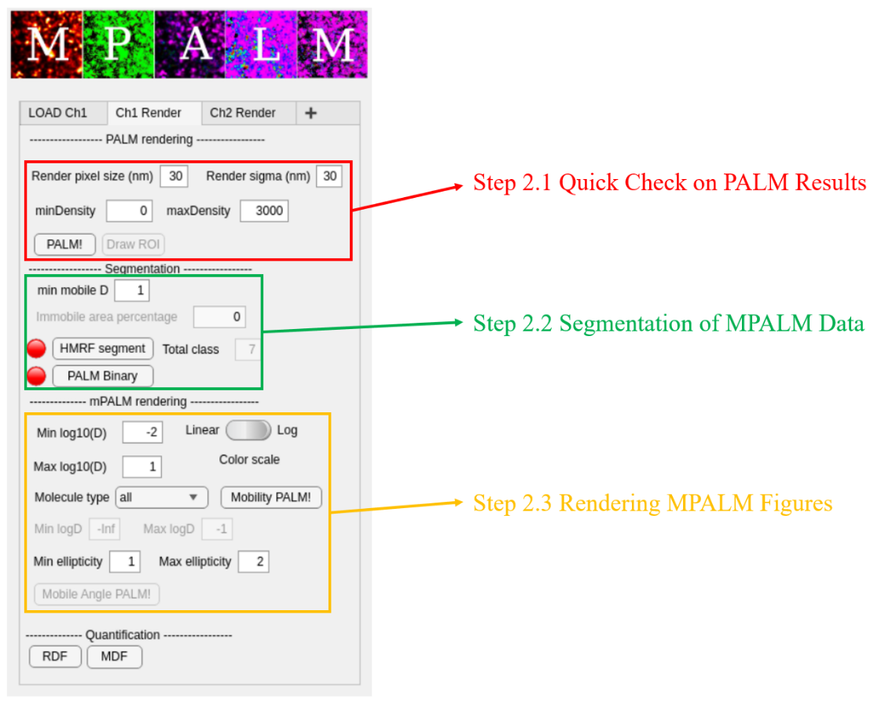

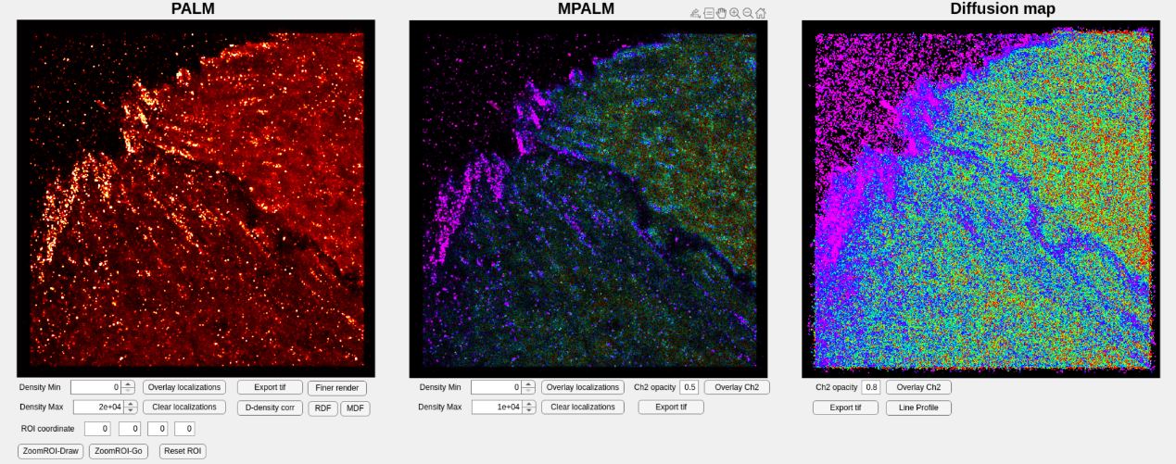Once the MPALM figures are generated, additional adjustments can be made to refine the results: **Density Min** and **Density Max** can be defined manually to adjust brightness of the rendered figure. Press the **Overlay Localizations** button can overlay color coded raw localizations onto MPALM figure. This provides a direct comparison between the raw data and the processed image. By entering the four coordinates of position, you can zoom in to your region of interest. By pressing **Export tif** button, you can save your final MPALM figure as a .tif file for further analysis or publication.